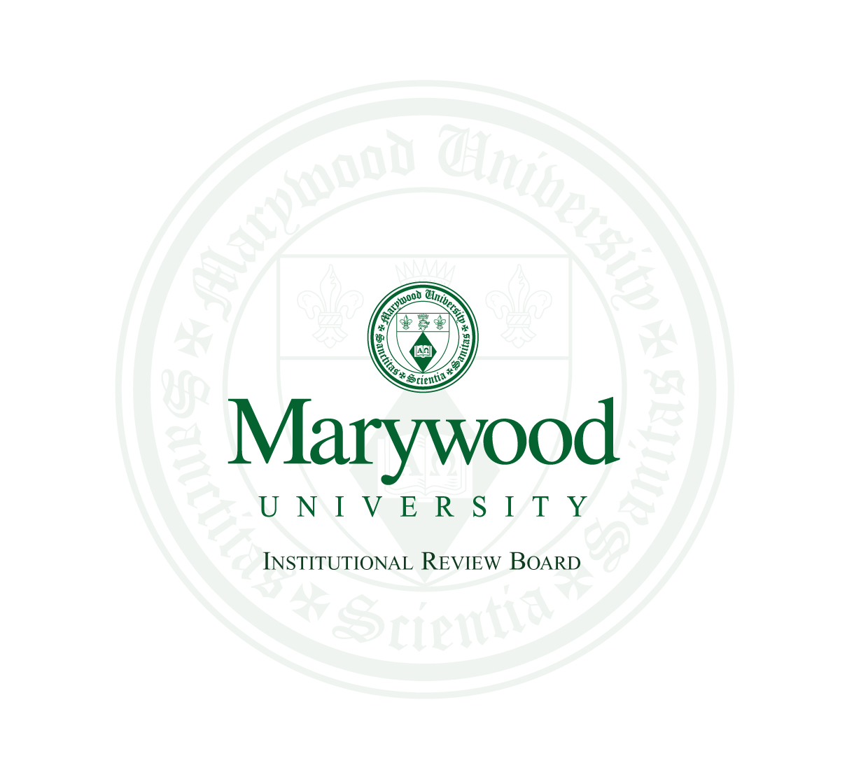
MARYWOOD UNIVERSITY
Institutional Review Board and Exempt Review Committee
2300 Adams Avenue, Scranton, PA 18509; (570) 348-6211, x.2418 or irbhelp@marywood.edu

Advertising Templates for Recruitment of Human Subjects

This document contains:
- Email Recruitment Template
- SONA Template (aligns with Psychology’s Online Recruitment System)
- Flyer Sample

Instructions:
- Please delete this entire page. Also delete any pages not being used.
- If using more than one template, save each as a separate document. Name each appropriately.
- Remove all bracketed sections, as they contain instructions for you only.
- Proofread your document(s) for spelling, grammar and punctuation.
- Review our Recruitment of Participants policy. It lists requirements for all research advertisements, as well as Marywood campus contacts for access to official email list-serves or social media accounts after approval.

Email Recruitment Template

Subject Line: [Insert the subject line that will appear in your email transmission]

Dear [Insert name or group/population]:

My name is [insert your name], and I am a [insert your role - e.g., graduate student, faculty member] at Marywood University. I am conducting a research study. Its purpose is [insert purpose of the study].

You are invited to participate in the study if you qualify. To qualify, you must [insert any inclusion/exclusion criteria for participants (e.g., be 18 years or older, be a student at Marywood, etc.; may be listed in bullet format if there are many]. The research will take place at [insert location (if known) or potential location; if online survey, state through an online survey site and name it]. It will take about [insert time commitment for participants].
Benefits may include [insert any benefits to the participant and/or field of study; payment or incentives cannot be considered a benefit for participants to weigh against risks - that’s addressed in the next paragraph].

For your participation, you may receive [only use this section if you are offering a payment, class credit, raffle entry, etc.; for class credits, mention alternative assignment].

Survey Link: [Only if the study takes place online via a survey site, enter the URL to the survey here - otherwise, remove this part; ideally, the informed consent form should appear as the first page reached by the participants after clicking the link.]

This study has been approved by [Insert either Marywood University’s Institutional Review Board - OR - Marywood University’s Exempt Review Committee].

Sincerely,

[insert your name]
[insert your contact information]

SONA System Template
[Insert Title of Study Here]

Brief Abstract
[This section is limited to 240 characters, including spaces. Keep under the limit.]
The purpose of this study is to [Explain research question and purpose in simple language].

Detailed Description
[This section is limited to 1500 characters, including spaces. Keep under the limit.]
You are invited to participate in a research study about [insert general statement about study].

If you agree to participate in this study, you will be asked to [Describe the location of the procedures. Explain all tasks - exactly what participants will do. If procedures take place over time or several visits, mention frequency. Explain assignment to study groups (if applicable). If class credits are offered, explain that an alternate assignment is available for students who do not wish to participate in the study.].

This study is being conducted by [state full name], a [indicate Marywood University affiliation, such as an undergraduate student completing a class research project, a graduate student completing a thesis, a doctoral student completing dissertation, etc.].

If you have questions about the research, you may contact the investigator at [provide phone number] or via email at [provide email address].

Eligibility Requirements
You must [explain any inclusion/exclusion criteria, if any - e.g., be a student at Marywood University] to participate in this study. You must also be 18 years of age or older.

Duration
[Length of time for participation]

Credits
[Number of credits given for participation]

IRBNet ID Number
[IRBNet Base Number, without the dash]

Study URL
[This section is for a link to a study URL for online studies only. If the study doesn’t have one, remove this section completely.]

[Flyer Sample]
[Your flyer does not need to follow this particular design, but should contain similar pieces of information.]
A study is being conducted to examine how different musical genres affect memory. Participation will include a visit to lab 1061 in
the McGowan Building at Marywood University. Participants will memorize words, listen to various pieces of music via
headphones, and then perform several recollection exercises.
The approximate time of the visit will be 30 minutes.

Benefits may include a better understanding of the cognitive
effects of music, and a research participant experience for
university students.

Eligibility:

- Undergraduate student at Marywood University
- Between the ages of 18 to 25 years old
Participants may earn .5 Psychology class credits if available via
their professor. Alternative assignments may also be completed to
earn such credit (see professor for details).

Musical Genres and Memory
Jamie Smith, Principal Investigator
Graduate Student at Marywood University
Phone: 570-555-5555 • Email: jamiesmith@m.marywood.edu

