Specific steps for scanning can vary somewhat depending upon the scanner and the software that comes with it. However, certain elements are fairly universal. This set of instructions is designed for a Hewlett Packard Scan jet using HP software.

## scanner keys most.jpgScanning Images

### Using the Buttons

The simplest way to begin a scan is to use the buttons that you see on the front of the scanner. **NOTE:** it isn’t necessary to press the power button on the scanner. When any of the other buttons are pressed, power automatically comes on.

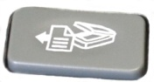

The **first button to the left** allows you to send the scanned image immediately into a Word document. Be certain that you are scanning in black and white for a clean background. You’ll note that scanning text often has numerous errors so be careful in proofreading.

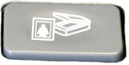

The **second button to the left** is one that you will probably want to use frequently. It scans the image as a graphic. Graphics can’t be edited but will appear exactly as seen on the scanner and can easily be inserted into a Word or PowerPoint document. Be certain that your settings will allow for a preview if you want only parts of the image scanned.

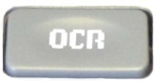

The **OCR button** (ocular character recognition) allows you to scan the document into a software program (iIris) that will then turn the scan into editable text, if desired. This provides a number of features before converting it into a Word document or PDF file.

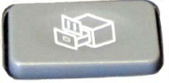

The **button to the right of OCR** allows you to determine what type of file format (PDF, TIF, RTF, TXT, HTML, Bitmap, etc.) and what location you would like to store the scanned file. Saving it, for example, as RTF would provide an editable file with much of the formatting remaining. Saving it as a bitmap file would make it a graphic with no editing capabilities.

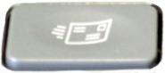

The **second** **button from the right** sends the scanned image as an Outlook email attachment. The window that comes up allows you to scan in color, grayscale or black/white; determine what file type you wish to send; etc. It then brings up an Outlook email window. **NOTE:** Unfortunately, if the individual to whom you are sending the message does not use Outlook, the email will not be seen. The better option would be to use the button described above that allows you to select a file format such as TIF or RTF and send it as an attachment with whatever email application you use.

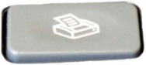The **last button on the right** sends the scanned image immediately to a printer. This makes scanning similar to a copy machine. If the image is text, be certain to scan it in black not color. If done in color, the background will have color (sometimes with a bluish tint if using a color printer) instead of a clean white.

### Beginning the Scan

First, it is important to keep in mind that the picture being scanned should be a clearly defined image. If it is blurred, it will scan blurred. You can use PhotoShop to clear it up somewhat, but the scan will be only as good as the image. Try to center the image on the scanning plate with the upper right edge of the object placed on the right upper-corner of the scanning plate. Most software will do some straightening for you but keeping it straight to begin with is helpful. If you’re scanning an open book, press lightly on the top of the scanner lid to eliminate as much light exposure as possible.

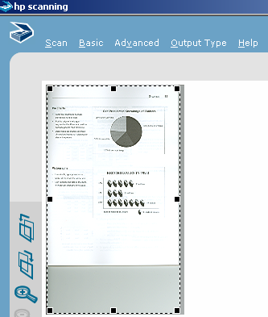After the object is placed face down, the top or cover of the scanner is firmly in place on top of the object, and the button pressed, the scan will begin. **NOTE:** if this is the first time the scanner is being used, it will take a moment to warm up.

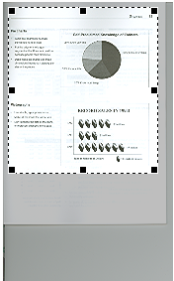

adjusted selection

Some software may have a menu option that allows you to click **Preview** before you scan.

1. You will see (and hear) an initial scan take place. Note that the image that has been scanned has a dotted outline with small black squares around it. This is your “selection” area. To reduce wasted space, click and hold on a black square. Pull in or out towards the area you want selected. Note the difference between the original selection and the adjusted selection on the images to the right.

original selection

1. Now click **Accept** or **Scan** depending on your software.

### Black and White Scanning

Some images need to be in black and white in order to achieve a crisp picture. This is certainly true when scanning musical scores but also true of any picture that is originally black/white. The reason is if the color setting is used, there could be a bluish hue around the periphery of the picture. Also very old and yellowed photos will sometimes scan better if black/white is used.

1. 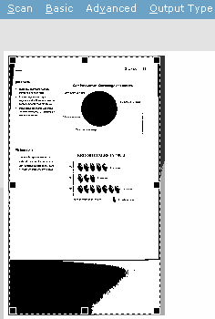With the HP software, one of the menu options is **Output Type**. When you click on this option, you will see a number of choices with the last one being **Black & White**. Click on the Black & White choice. **NOTE:** this option is sometimes not active. It is always active if used through an application such as PhotoShop or Word.
2. The scanned image will change almost immediately to a black and white image that generally looks pretty disgusting. Don’t be alarmed; this is a miniature. The actual scanned result will be smooth and distinct.
3. After moving the selection tool to encompass just the part you want (see the previous Step #2 under **Beginning the Scan**), click **Accept**.

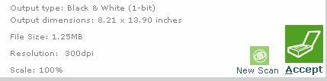

### Saving the Scan

1. Now that the scan is complete, you need to decide what type of formatting you want to save it in. (TIFF, JPG, BMP, WMF are just a few examples). Keep in mind how you plan to use the image. Will it simply be saved somewhere on your hard drive in which case you don’t have to worry too much about the size of the picture, or will you be uploading it to a web page or sending it as an attachment in an email? Uploading and email attachments should be in the smallest format possible. Usually JPG or TIFF is the safest setting to use for this purpose.
2. The completed scan will be seen in an application such as HP Photo and Imaging Gallery.
3. Go to **File/Save As** and give the image a name. Then select the type of image in the area, **Save as Type**.

## Scanning Text

It is essential that the text is distinct and preferably on a white background. Graphics and tables may not look the same as the original. Also, keep in mind that some letters might be misinterpreted. An M could be interpreted as an N or a C might be an O. Some software will provide proofreading after the scan and before it is put into an application such as Word. I.R.I.S. puts it immediately into Word where you can then do the necessary proofreading.

1. Place the page face down and as straight as possible on the scanner plate. Lower the lid. If you are scanning a book or something that is thick, you’ll need to apply a bit of pressure on the lid to avoid light leakage.
2. The easiest way to begin is to press the **OCR** button on the front of the scanner. If programmed correctly, it will scan directly into Word.
3. If the button does not appear to be active, locate your OCR (ocular character recognition) program through the **Start menu**. On our machines, it is probably **I.R.I.S.** Omnipage is another common application to read text.

### Scanning Multiple Pages to be Placed in One File

Follow all of the steps above (just click the **Scan button** for each additional page). When all pages have been scanned, click **Done**.

## Scanning Negatives or Slides

1. Lift the lid and remove the white plate. This easily lifts off and can be snapped back into place when finished.
2. Insert the negative or slide using the holders revealed with the plate is removed.
3. Close the lid and press the button on the left of the OCR button.
4. A window will appear asking what you want to scan. Click the appropriate button.
5. At this point you will note that the scanner lamp is warming. This may take some time so be patient. It will seem like nothing is happening; however, you will hear the scanning process begin after a period of time.
6. Once it has scanned, if you are using multiple slides or negatives, you will notice that only one is selected. One image at a time will be scanned. At this point you might need to adjust slightly the area to be scanned to better fit the image.
7. 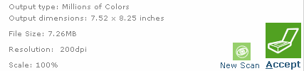You may also need to rotate if the image is upside down. Go to the menu item **Basic** and select **Rotate**. You will need to click **Rotate left** or **Rotate right** twice in order to get the image right-side up.
8. Now click **Accept**.
9. When the scan is complete, you will see a window asking if you wish to scan another. If you have the negative strip or multiple slides loaded, indicate **Yes**.
10. Move the selection area to the next slide by holding the mouse down on the image that was just scanned (you’ll see a 4-sided arrow as a cursor) and dragging it to the next image to be scanned.
11. Click **Accept**.
12. When finished, indicate **No** when you are asked if you want to scan another image.
13. HP Gallery will should automatically appear on the screen after a brief period of time with each image showing as a separate file. Double-click the image so that you can crop, make color adjustments, and other options to make the picture “perfect.”